

Specification

for

SQL Server Log & SQL Agent Error Log Alerts

Robert Wilkinson

10/22/2008



Proprietary and Confidential to BBS Technologies, Inc.

© 2008 BBS Technologies, Inc.; all rights reserved.

Revision history:
When? | Who? | What?
10/13/2008 | Robert Wilkinson | First Draft
10/22/2008 | Robert Wilkinson | Revised Draft based on dev comments
10/30/2008 | Robert Wilkinson | Final Draft

Table of Contents
1. Revision history: ii
2. Table of Contents iii
3. Requirements 1
3.1. Overview/Purpose 1
3.1.1. Related Customer Requests 1
3.2. Target Users 1
3.3. Use Cases 1
3.4. Feature/Function Market Requirements 2
3.4.1. Required Functions 2
3.4.1.1. Configuring the Log Alerts 2
3.4.1.2. Viewing the Log Alerts 2
3.4.1.3. Clearing Log Alerts 3
3.4.1.4. Current Real Time Logs View 3
3.4.2. Non-Supported Functions 3
3.5. Open Issues 3
4. Functional Design 4
4.1. User Interfaces 4
4.2. Installation and Upgrade 6
4.3. Permissions and other Required Configuration 6
4.4. Licensing Issues 6
4.5. Dependencies 6
4.5.1. Dependencies on Idera Software 7
4.5.2. Third-Party Software Required on the Customer Machine 7
4.5.3. Third-Party Software Required Internally 7
5. Internal Design 7
5.1. Architecture 7
5.1.1. Desktop Client Changes 7
5.1.2. Collection Service Changes 7
5.1.2.1. Evaluating SQL Server Log & SQL Agent Alerts 8
5.1.2.2. Collection Service Data Flow 8
5.1.3. Repository Changes 9
5.2. Installation Issues 9
5.3. Schedule 9
5.3.1. Work Breakdown and Sizings 9
5.3.2. Areas of Risk 9
6. Quality Assurance Considerations 9
6.1.1. Overview 9
7. Documentation Considerations 10
8. Bibliography 10

Requirements

Overview/Purpose
There are many valuable sources that can be used for monitoring and discovering SQL Server problems. SQLdm monitors many of these, but one area that we have not taken advantage of enough is the error logs. SQL Server maintains a wealth of information in the SQL Server and SQL Server Agent logs. A lot of the messages contained in these logs are purely informational, but many contain important information regarding errors that may have occurred or other event of interest. Most DBAs routinely review these logs at least once daily to spot problems, which can be a time consuming process depending on the number of messages logs. In order to help automate this process, SQLdm will introduce two SQL Log Alerts, one for the SQL Server Log and one for the SQL Agent Error Log. The two alerts will allow users to automatically scan the logs for events of interest and generate an alert when they are encountered. This feature should greatly reduce the amount of time users spend reviewing SQL logs and should keep users informed more rapidly when problems arise. The two alerts will be identical except when noted.

Related Customer Requests

PR 10520 - FRQ: Alerting on errors found in the SQL Server Log
Customer would like DM to send alerts when an error is written the SQL server log for a monitored server:

"Also another nice feature would be the ability for DM to parse the SQL Server logs and send out an alert if it read there was a SQL Server error recorded. Any chance of that happening? "

SalesForce Cases - 18561, 7768, 5182
Is there a way to setup SQLdm to send an alert when there is a warning and/or error in the SQL server log? I'm currently monitoring some memory problem with our SQL server, and the warning that I would like to be notified of is as follows:
WARNING: failed to reserve contiguous memory of Size=65536.

Target Users
SQLdm users (typically DBAs) that need to be alerted when a specific event is logged to the SQL Server log or the SQL Agent Error Log

Use Cases
The following use cases outline user scenarios and tasks that should be supported by SQL Server Log & SQL Agent Error Log Alerts:
- Users should be able to automatically raise alerts and receive notifications when events are written to the SQL Server Log or SQL Agent Error Log.
- Users should be able to raise alerts and receive notifications when specific severity events are written to the SQL Server Log or SQL Agent Error Log.
- The user should be able to specify exact text or text patterns on which to match for raising alerts when scanning the SQL Server Log or SQL Agent Error Log.
- The user should be able to view SQL Server Log & SQL Agent Error Log alerts in the Alerts view.
- The user should be able to clear the SQL Server Log & SQL Agent Error Log alerts manually.
- The user should be able to see configured warning and critical messages appropriately displayed in the SQL Server Log & SQL Agent Error Log on-demand view.

Feature/Function Market Requirements

Required Functions

Configuring the Log Alerts

- Users will be able to configure an alert based on text in the logs. A user will be able to specify separate text for both warning and critical levels. One or both levels may be used.
- Users will also be able to configure alerts based on the severity of the error message in a log. See (1) for a description of the severity levels. The limit will be:
  - 0-25 for SQL Server Logs
  - 1-3 for SQL Agent Error Logs

When SQLdm scans the SQL logs, any match will result in an alert being raised for the appropriate alert level. We will provide a list of some default expressions based that can be used as search text for the alert.
The list will include default search strings for the following:
- Login Failed
- Backup failure
- Server Restart
- Any Error entry in the log

Note: We already have alerts for Job Failures and Server Stopped/started.

Viewing the Log Alerts

The Log Alerts can be viewed in the same manner as any SQLdm Alert, using the Alerts view. A new filter will be provided so users can single out log alerts if so desired.

The contents of the alert will be the line that matched the search text, plus one line before the math and one line after the match.

The SQL Server Log view features an icon indicating the warning/error status of each message. The thresholds configured by the user will be applied in this view as well.

Clearing Log Alerts
SQL Server Log & SQL Agent Alerts are similar to Table Fragmentation and Long Running Job alerts; we will not auto-resolve (clear) these alerts. Users will be provided an option to manually clear these alerts when they are no longer needed, otherwise these alerts will affect the state of the server until cleared. Once again, note that we will not continually raise these alerts. New alerts will only be raised if a new log event that matches the user-defined text expressions is written.

Current Real Time Logs View
The current real time log view will be changed to match the current alert terminology. The log entries will be changed to critical from error and warning from informational.

Non-Supported Functions
We are not supporting scanning the Windows Event Log. We are limiting this feature to the SQL Server and SQL Agent Error Logs

This feature will not alert on log entries that occurred during maintenance mode.

Open Issues
- How do we want to indicate to the user that an error log could not be read?
TM - We should probably write to out collection service log at the least. In what situations could occur? If they are pretty much all edge cases, noting it in our log is probably fine.

- How should we handle the scenario where we can only read part of the log? For example, we only need to read the last five minutes of logs, but a server restart occurred in the five minutes and caused the log to cycle.
TM - I would say we only read within the current log file, but there may be reasons for an alternative solution.

- Do we want to limit the number of error log lines we will allow to be read per refresh, like the flood control in OS Metrics? If so, how do we want that to work?
- Do we want to put a limit on the size of log that we will read in? Extremely large log files can put a lot of pressure on the monitored server and we can detect the error log size before we read. Maybe we could read the last 100 or 1000 events or 10MB, which ever comes first.
- The log view already does some text matching for errors and warnings. Do we want to include these as defaults in the alert configuration? In the real time view, we currently have a filter the log so that it only shows just errors, just warning, informational message or any combination of the three. We also allow searching in the message text, message source and the message number.

Functional Design

User Interfaces

Two new standard alerts will be added to the available SQLdm alerts in the Alert Configuration dialog, SQL Server Log and SQL Agent Error Log.

These alerts will only provide options for Warning and Critical alert levels. One or both alert levels may be used. The data provided for these alert levels will be one or more user-defined text expressions that will be manually entered in a similar fashion to the method used in the Advanced Alert Configuration dialog for job alerts (shown below). The user will be able to specify include filter text or exclude filter text.
The user will also be able to enter a regular expression for text matching. A textbox will be provided for the user to enter the regular expressions, one regular expression per line.

Note: The user will only be able to specify exact text matching or a regular expression but not both.

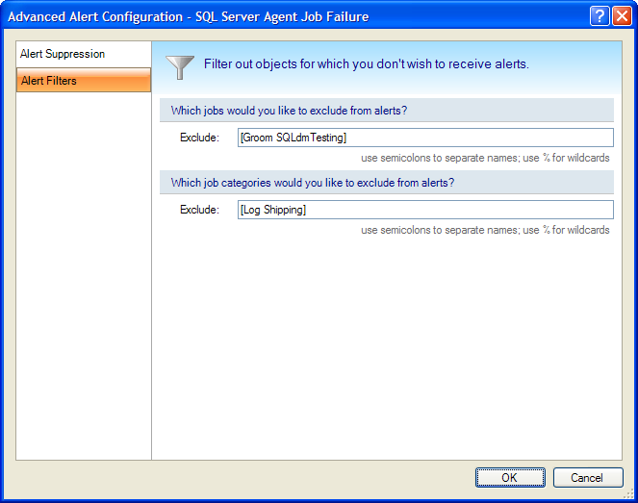

To configure the severity portion of the alerts, the standard SQLdm slider will be used (see below).
The defaults will be:
- SQL Agent Error Log
  - 2 – Warning
  - 3 – Critical
- SQL Server Log
  - 11 – Warning
  - 18 – Critical
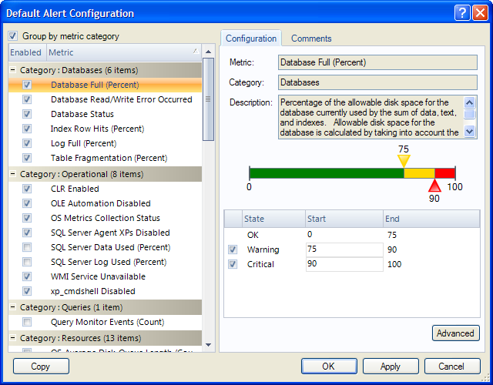

Installation and Upgrade
The repository will be upgraded to support the new alert

Permissions and other Required Configuration
Only SQLdm users with Modify rights and higher can configure SQLdm Alerts.

Licensing Issues
None at this time.

Dependencies
None at this time.

Dependencies on Idera Software
None at this time.

Third-Party Software Required on the Customer Machine
None at this time.

Third-Party Software Required Internally
None at this time.

Internal Design

Architecture

Desktop Client Changes
- Add the new alert to the Alert Configuration dialog.
- Add the log text search strings to the Advanced Alert Configuration dialog.
- Change the On Demand log view to display the appropriate warning or critical messages.

Collection Service Changes
The collection service will perform the log searching. For exact matches and wildcard searches, the search will be performed as a part of the SQL query. For Regular Expression matching, the log text will be pulled back to the collection service and the regular expression matching will be performed in the service.
Error severities for the SQL Agent log will be based on the ErrorLevel column in the log. In the SQL Server log there is no error severity column so we will have to detect errors with a regular expression. The SQL Server log may not always show a message along with an error code and severity.
Unless the SQL Error Log severity matching is dropped, the upshot of this is that the SQL Server log will always be read back to the collection service.

There will be a limit default “flood control” limit of 1000 log lines. This value will be configuration via a service wide setting in the collection service configuration file.
Note: The data will not be collected during the scheduled refresh if the alert is disabled.

Evaluating SQL Server Log & SQL Agent Alerts
A new collector will be added to the SQLdm Collection Service that will read in the most recent SQL Server Log and SQL Agent Error Log entries and evaluate the provided text expressions to determine if alerts should be raised. By "recent SQL log entries," I mean we will only read in new entries since the last scheduled refresh. The logs can grow quite large, so we only want to evaluate as few log entries as necessary (See Open Issues). It should be noted that if no text expressions are provided, the SQL logs will not be scanned.

When new alerts are generated, those alerts will be passed to the SQLdm Management Service for storage and notification processing

Users will be able to match SQL Server/SQL Agent log text in one of three ways
- Exact text matches – e.g. “begin stack dump”
- Wild card text matches using the standard % indicator – e.g. “SQL Server is terminating%”
- Regular expression matches – e.g. “Backup device '.+' failed to create”

Both exact text and wild card matches will be automatically available in the entry field (as currently used elsewhere in the Advanced Alert Configuration screens). Regular expression matches must be enabled by checkbox: no syntax assistance will be provided for regular expressions. Invalid regular expressions will be logged to the collection service log. However, all of the regular expressions will be logged to the collection service log if log is in verbose mode.

Collection Service Data Flow

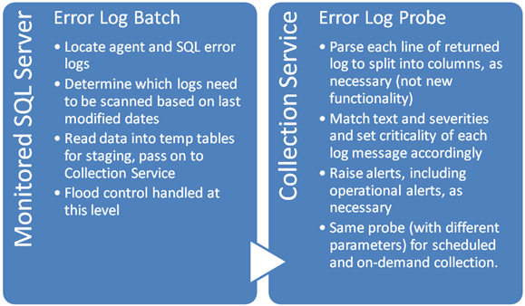

Repository Changes
The repository will be upgraded to support the new alert.

Installation Issues
None at this time.

Schedule

Work Breakdown and Sizings
Component | Who | Sizing (Days)
Desktop Client | Robert | 2
Collection Service | Vicky | 3
Repository Changes | Robert | .5
Total |  | 4.5

Areas of Risk
- It is possible that the user could specify a very poorly formed regular expression. But because we will only be applying the expression to one line of the log at a time, it should only have a negligible impact on performance.
- It is possible, however unlikely, that an error log will be unmanageably large and cause problems to either the monitored server or the collection service.

Quality Assurance Considerations

Overview
None at this time.

Documentation Considerations
We will need to document the various error severities for the logs or provide links to the SQL Server documentation for this area.

Bibliography
- http://msdn.microsoft.com/en-us/library/aa937483(SQL.80).aspx

